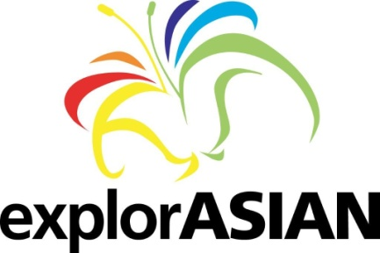
Request from Community Partners for having their program/event
promoted by VAHMS
This is a free service provided by VAHMS to other community partners. VAHMS has the discretion to promote it through any of their explorASIAN promotional channels (e.g. webspages, on-line calendar, FB page or twitter) as appropriate, and only at the best of their volunteer capacity.
The following info must be provided at least 10 days in advance of the first date of the event, even if you’ve attached a poster. Requests can be made on our website www.explorasian.org or by emailing to office.vahms@gmail.com
Organization that makes the request:
Name of the event:
Date (s):
Time: (start time & end time):
Venue:
Description (under 50 words):

Website/tel (for enquiries or tickets):
Name of applicant & email (for VAHMS use only):
If you would like to have your event designated as a signature program of the explorASIAN festival in May, a longer description of the program must reach the VAHMS office not later than Jan. 31, 2014. Only programs with the highest standard and programs that speak to the theme of identity, hybridity and social integration will be considered. Someone from the Board will get back to you for further discussions if necessary.

