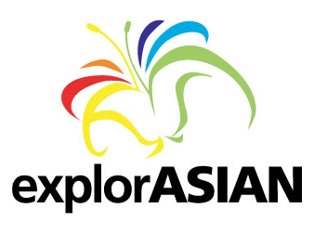
Vancouver Asian Heritage Month Society
Community Partners Guidelines
Events taking place outside of explorASIAN Festival 2016

The Vancouver Asian Heritage Month Society (VAHMS) is both a community
builder and bridge builder. For 19 years, we have successfully brought the Pan-Asian Community and others together to share in unique intercultural events, during the month of May and throughout the year. As a group of dedicated volunteers, together we can bring strength, harmony, education and understanding.

As a non-profit society, we provide a free service to support our cherished community partners, promoting your events through our explorASIAN channels. VAHMS, at its discretion, will promote your events through any of our explorASIAN promotional channels.

Guidelines

In order to make the community partnership successful for all, please use the
following guidelines:

• We will accept posters for the VAHMS website for events taking place at other
times of the year, excluding Asian Heritage Month (May) 10 days before the
requested event - please have the format of images in JPG.

• Events should be accessible to everyone in the community; please ensure there
are English translations or explanatory remarks in English for your program.

• Provide reciprocal publicity by using the attached explorASIAN logo in all your
promotional materials.

• Provide VAHMS with complimentary tickets to your event when possible.

Submission Instructions

Please send poster to VAHMS coordinator, Eleanor Munk, at office.vahms@gmail.com
10 days before the event. Someone from VAHMS will get back to you for further discussion as necessary.

Along with the poster, please complete the following information so that we may contact you as needed:

Event Title:
Venue Name:
Date:

Contact name:
Email:
Confirm Email:
Description:
Website:
Thank you for your interest and collaboration with VAHMS.

